CSCI 2302

UNIX Account

Log In, Compile, Run Programs, & Submit Programs

Create Folders in Unix

To gain access to the cs server, you will need to use SFA’s VPN. Then you will need to sign into the cs server. To sign into the server, you need a terminal window. You can download an environment or use a terminal window on you machine. If you wish to transfer files onto the cs server, you have two choices: 1) use a terminal window and the scp command, or 2) download and install a GUI FTP service.

Contents

SFA VPN 2

Account Format 3

To Transfer Files from Your Computer to the CS Server Using a Terminal Window 3

Mac users 4

To open a command window: 4

To copy file from local machine to the cs server: 4

To Transfer Files from Your Computer to the CS Server Using a GUI environment 4

Filezilla 4

Start FileZilla 4

WinSCP: 5

Log In to WinSCP 5

To copy file from local machine to the cs server: 6

Logging into the CS Server: 7

Terminal Window App 7

Mac Users: 7

Window Users 7

Using Computer Terminal Window App: 7

PuTTY 8

Compiling, Running, & Submitting Programs on the CS Server 11

To Compile Programs 12

To Run Programs: 12

To Submit Programs: 12

To verify what you have submitted: 12

To remove a file that you have submitted: 13

To remove all the files that you have submitted: 13

To Make a Folder/Directory: 13

To change Folders/Directories: 13

To See/View Contents in a Directory: 14

Copy Command: 14

To Remove a file: 14

Don’t forget to logout! 14

# SFA VPN

You will have to use the SFA VPN to log onto the cs server if you are not on the SFA campus and in some cases – even on campus.

<https://help.sfasu.edu/TDClient/2027/Portal/KB/ArticleDet?ID=86075>

The site will walk you through setting up on a mac and on a pc.

Make sure this is set up and working prior to logging into the cs server. Try to connect to D2L to make sure it works.

Now that you know it works, anytime you need to access the cs server, start the SFA VPN.

PC: Click on the Show Hidden Icons button, and connect:

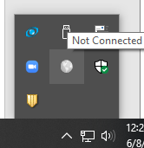 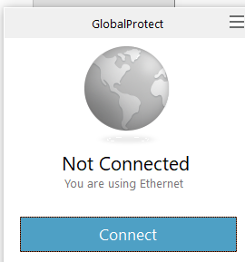

# Account Format

All accounts follow the form: **csci2302-00snn** where nn is your 2-digit individual code (all lowercase - UNIX is **CASE SENSITIVE**), and s is the section.

ie: csci2302-00**1**nn is for section **001,** csci2302-002nn is for section **002**.

You may change your password once you have logged on using the following command:

**passwd** (yppasswd on some older systems)

You will be prompted for the old password, the new password and a verification of the new password. If you have trouble with this command you may type the command below (note: yppasswd is the network version)

**man passwd**

If you choose to change your password and you forget it/lose it, I cannot help you figuring out your password. We will have to contact Dr. Ogale to reset your account, this will take time.

Do NOT forget to use the SFA VPN to access the cs server off campus – and maybe on campus too.

# To Transfer Files from Your Computer to the CS Server Using a Terminal Window

In a terminal window that is accessing your machine:

* At the command prompt, enter:

scp filepath/file.extension cscs2302-00snn@sfasu.edu

where you supply the ***complete/absolute*** file path of file you want to transfer over (finding the complete path is sometimes very difficult to do!)

Mac users:

Mac users need to open a command window and then will use the scp command, secure copy command. (For more information checkout [GeeksForGeeks](https://www.geeksforgeeks.org/scp-command-in-linux-with-examples/).)

### To open a command window:

On your Mac, do *one* of the following:

* Click the Launchpad icon https://help.apple.com/assets/5D92A6940946227D4301035B/5D92A6A50946227D43010362/en_US/3cc1cbefea3e97e575172177e505b7a9.png in the Dock, type Terminal in the search field, then click Terminal.
* In the Finder https://help.apple.com/assets/5D92A6940946227D4301035B/5D92A6A50946227D43010362/en_US/937fa92677a2c49a18fa81070e5d8419.png, open the /Applications/Utilities folder, then double-click Terminal.

You might want two windows, one to login to the cs server and one for your local machine.

### To copy file from local machine to the cs server:

At the command prompt, enter:

scp file.java csci2302-00snn@cs.sfasu.edu

where file.java is the file – with the absolute file path - you want to transfer over to the cs server in your account.

# To Transfer Files from Your Computer to the CS Server Using a GUI environment

Mac users: Filezilla

Window users: Filezilla or WinSCP

## Filezilla

For Mac & Window users

Filezilla is a free software, cross-platform FTP application, consisting of FileZilla Client and FileZilla Server. Client binaries are available for Windows, Linux, and macOS, server binaries are available for Windows only. <https://filezilla-project.org/index.php>.

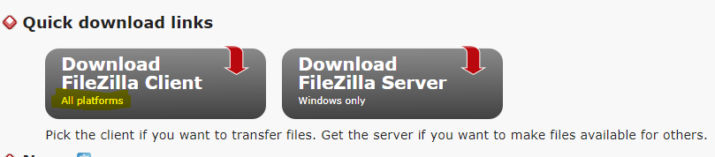

Start FileZilla:

Once you have installed FileZilla, you can access FilZilla through the Start Button / Applications Folder.

Host: cs.sfasu.edu

Username: cscs2302-00snn

Password: does not show, **but does have** circle icons for each character

Port: 22

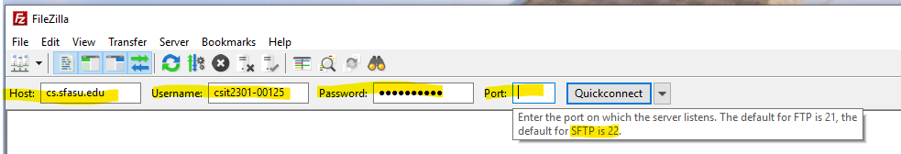

You now have an environment where you can drag and drop files/folders between.

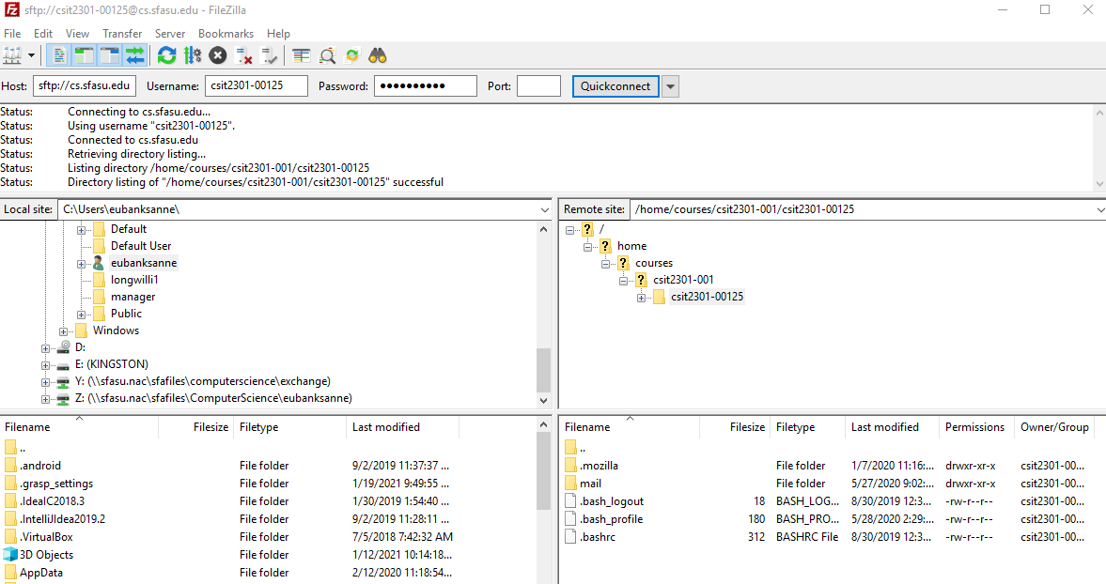

WinSCP:

Window users only!

Window users can log in to WinSCP to transfer the file from the local drive to the cs serer.

### Log In to WinSCP

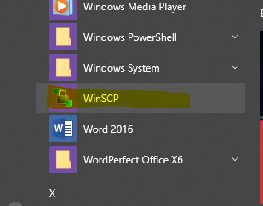

Host Name: cs.sfasu.edu

User name: csci2302-00snn

Password: your password provided to you or the one you have changed it to

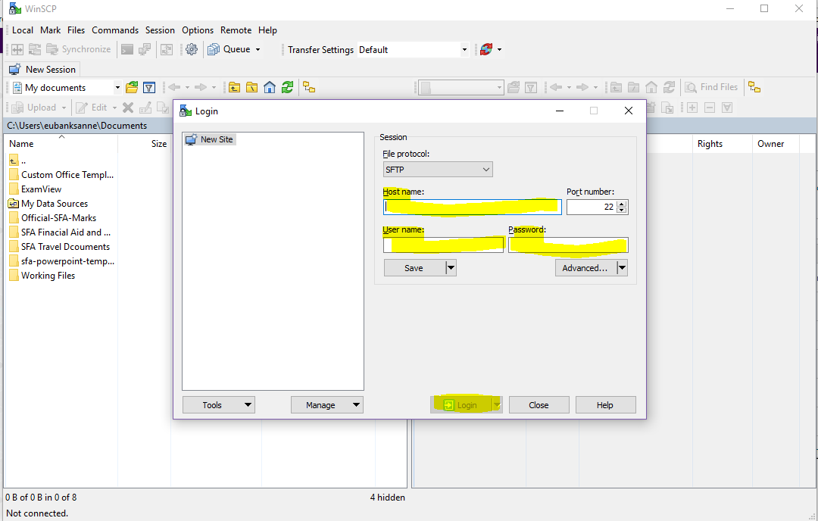 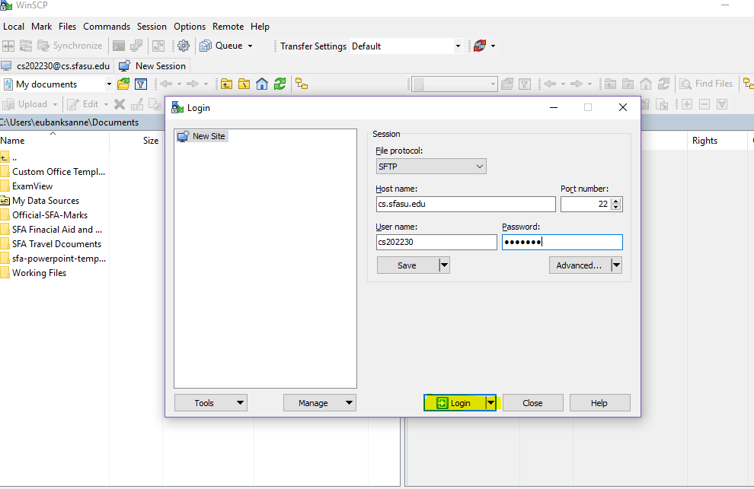

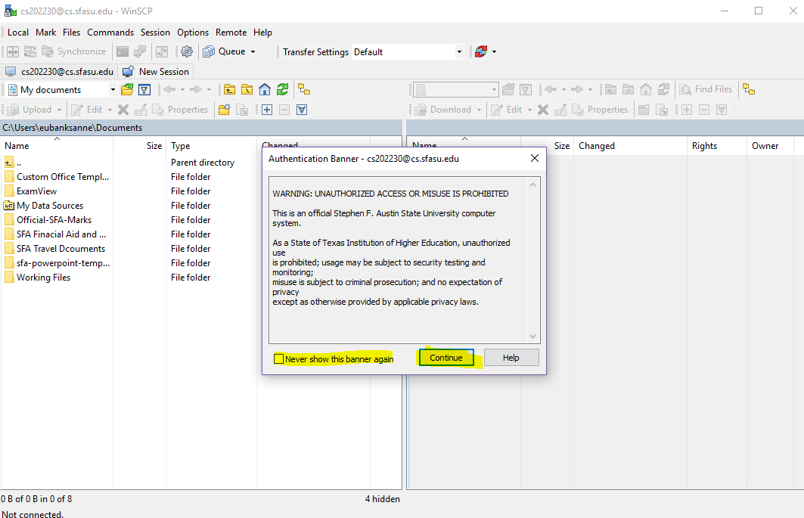

### To copy file from local machine to the cs server:

You can now drag and drop files from your computer to the cs server.

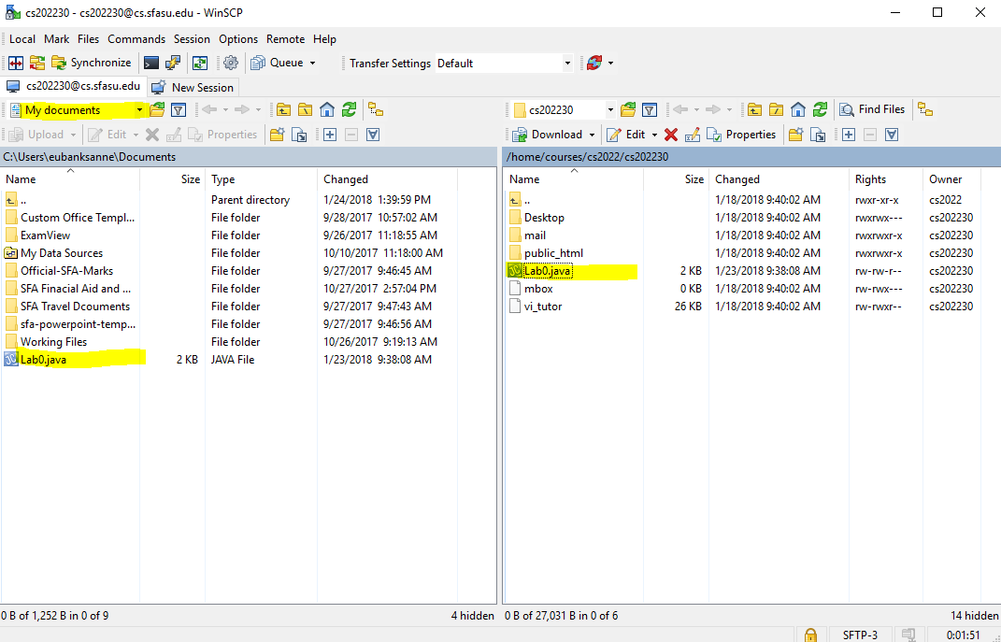

Don’t forget to terminate the session when exiting WinSCP.

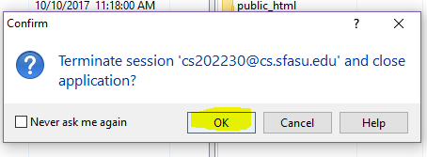

Once your program is on the cs server you can open **PuTTy** and compile your program.

# Logging into the CS Server:

You will need a terminal window to interact with the cs server. You have 2 choices: 1) use a terminal app or 2) use PuTTY.

Terminal Window App:

## Mac Users:

go to Finder, and select Go -> Utilities from the top menu. Then look for Terminal. Terminal can be used to get a local terminal window, and it supports SSH connections to remote servers.

Window Users:

install Windows Terminal from the Microsoft Store.

## Using Computer Terminal Window App:

In the terminal window, at the command prompt, establish a SSH connection to the cs server:

* + ssh username@cs.sfasu.edu
    - where username is the cs account name
* If you see a message about RSA key, enter yes
* You will be prompted to enter your account name (csci2302-snn)
* You will be prompted to enter your password.
  + Note: ****When entering your password, the cursor will not move (it is a security feature).*****

You now have signed in to the cs server.

Don’t forget to logout!

If you log into a system, you should log out. Security!

## PuTTY

You can download and install the PuTTY software – it works for macs and Windows. PuTTY is a free and open-source terminal emulator, serial console and network file transfer application. It supports several network protocols, including SCP, SSH, Telnet, rlogin, and raw socket connection. It can also connect to a serial port.

To install PuTTY on your computer:

PuTTY for macs: <https://putty.en.softonic.com/mac/download>

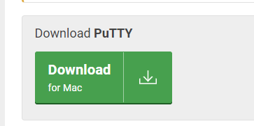

PuTTY for Windows: <https://www.chiark.greenend.org.uk/~sgtatham/putty/latest.html>

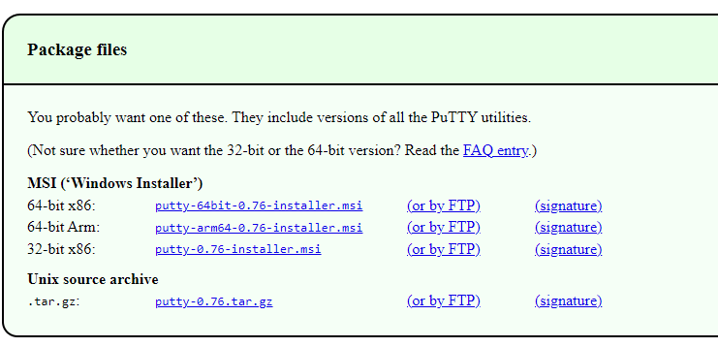

**OR Scroll down** to Alternative binary files and download the putty.exe

* Double click on the downloaded file to install PuTTY, usually located in the in the Download folder.

### Start PuTTY

Once you have installed PuTTY, you can access PuTTY through the Start Button/Applications Folder:

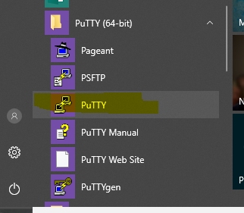 

Host Name: cs.sfasu.edu

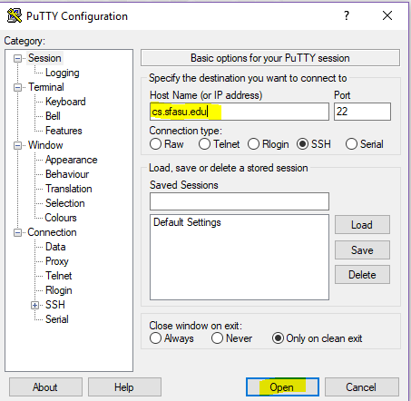

Choose the Yes button:

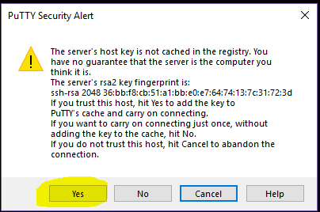

Login: with your cs account, csci2302-00snn

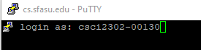

***When entering your password, the cursor will **not** move (it is a security feature).***

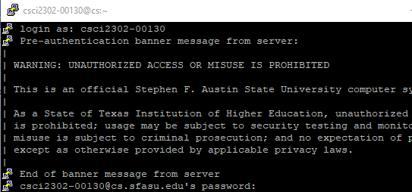

PuTTy is ready for use.

If PuTTY is timing you out before you are able to enter your password in, try to modify the keepallives.

When you first start PuTTY (prior to accessing the cs server), click on the Connection, at the Seconds between keepalives, change that value to another value in the range from 5 to 30.  FYI:  keepalives is a message sent by one device to another to check that the link between the two is operating, or to prevent the link from being broken.

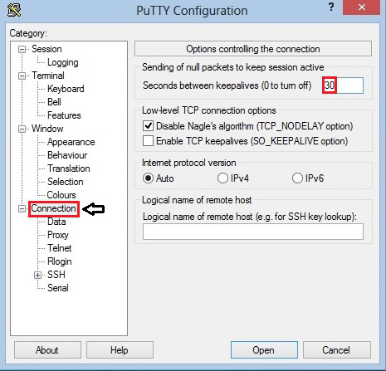

# Compiling, Running, & Submitting Programs on the CS Server

Keep in mind that UNIX is case sensitive!

Before you compile your program, make sure it is there and you have permissions to run the program.

The chmod command changes permissions:

chmod 755 file.ext

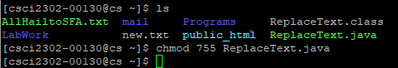

To see the change of permissions on the file:

ls -l (that is a lower-case L, lower-case S, space, hyphen, lower-case L)

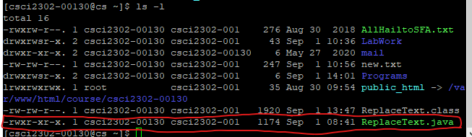

The command ls displays/lists the contents in a directory:



To Compile Programs:

javac ProgramName.java



A successful compile returns nothing.

## To Run Programs:

java ProgramName



## To Submit Programs:

**Only submit text files or .java – not binary files (.class files)!!!**

Submit to the Instructor Account: csci2302s

submit csci2302-00s ProgramName.java

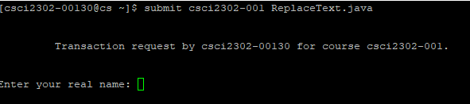

The first time you submit, it will ask for your name; type in your name.

You will receive confirmation of submission.

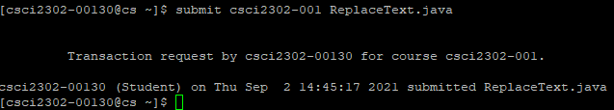

## To verify what you have submitted:

submit –l csci2302-00s (that is a lower case L)

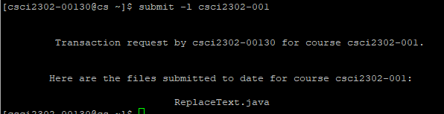

## To remove a file that you have submitted:

submit –r csci2302-00s ProgramName.java

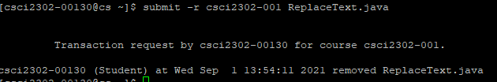

### To remove all the files that you have submitted:

submit –r csci2302-00s

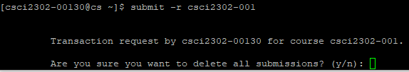

It will ask for verification.

# To Make a Folder/Directory:

mkdir FolderName

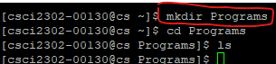

# To change Folders/Directories:

cd FolderName

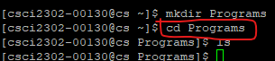

# To See/View Contents in a Directory:

ls (that is a lower-case L and a lower-case S)



ls -a displays all contents (including hidden ones)

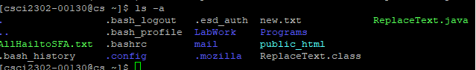

# Copy Command:

cp copy files and directories

The cp command makes copies of files and directories.

The form of the command is cp source destination

You **have to specify** the correct file path for the source and for the destination

Examples:

recursively copy to the back up: cp -R ~/files ~/files-backup

copy contents in the parent’s directory’s sub folder graphics to the HW folder here:

cp ../graphics/* HW

copy the Prog.java that is located in the parent’s instr folder here:

cp ../instr/ ReplaceText.java .



# To Remove a file:

rm filename.extention

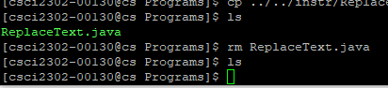

# Don’t forget to logout!

